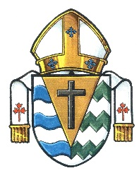
Annual Diocesan Appeal Schedule

Building Together in Faith

Weekend | 2015 | 2016 | 2017
Kick Off | September 13-14 | September 10-11 | September 9-10
Educational | September 19-20 | September 17-18 | September 16-17
Needs of the Canadian Church | September 27 | September 25 | September 24
Promotional | October 3-4 | October 2-3 | September 20- October 1
Commitment |  | October 15-16 | October 14-15
World Mission Sunday | October 18 | October 23 | October 22
Commitment | October 25-26

